ASSIGNMENT 1
Q1. Explain the difference between frontend, backend, and full-stack development with
suitable real-world examples.
ANS. Frontend development is focused on the part of the application users see and interact with—this includes layout, design, text, buttons, and overall look and feel, typically created using HTML, CSS, and JavaScript frameworks (like React or Angular). Example: When you open a shopping website, everything you visually interact with—product listings, shopping cart buttons—are built by frontend developers.​
Backend development is what happens on the server; it includes databases, server logic, authentication, and communication with other services. Technologies include Node.js, Python, Java, Ruby, and SQL/NoSQL databases. Example: When you place an order on an e-commerce site, the backend processes the order, stores it in a database, and handles payment.​
Full-stack development spans both frontend and backend, handling the whole system end-to-end—a full-stack developer might design the interface, build the APIs, and manage the server and database. Example: A single developer who builds a blog website where they create the page layout, handle user logins, and store blog posts in a database.

QUES.2 Create a simple diagram showing how the client-server model works in web architecture.
ANS. REQUEST
SERVER
CLIENT
RESPONSE

QUES.3 Describe how a browser requests and displays a web page from a web server.
ANS.
- User enters URL in the browser.
- DNS Lookup: Browser contacts a DNS server to translate the website URL to an IP address.
- HTTP/HTTPS Request: Browser sends an HTTP request to the web server's IP address.
- Server Responds: Server sends back files (HTML, CSS, JavaScript, images).
- Browser Renders:
  - Parses HTML to build the DOM tree.
  - Applies CSS for styling.
  - Executes JavaScript for interactivity.
- User Sees the Page.
The browser may continue making additional requests for other page resources.
QUES.4 Identify and list the tools required to set up a web development environment. Explain the
purpose of each.
ANS
Tool | Purpose
Code Editor | Write and edit code (e.g., VS Code, Sublime Text)​.
Web Browser | Preview and test websites (e.g., Chrome, Firefox)​.
Version Control | Track code changes/collaborate (e.g., Git)​.
Runtime | Execute code (e.g., Node.js for JS, Python for backend)​.
Terminal/CLI | Run commands, install packages, manage files​.
Package Manager | Install libraries/frameworks (e.g., npm, pip)​.

QUES5. Explain what a web server is and give examples of commonly used servers.
ANS. A web server is hardware/software that stores, processes, and delivers web pages to clients over the internet using HTTP/HTTPS.​
Common Web Server Software:
- Apache HTTP Server (open source, widely used)
- NGINX (high performance, also a reverse proxy)
- Microsoft IIS (for Windows environments)
- LiteSpeed
- Node.js (for JavaScript-based server apps)
QUES.6 Define the roles of a frontend developer, backend developer, and database administrator
in a project.

ANS.
- Frontend Developer: Designs and builds the user-facing part of the website or app, working with HTML, CSS, JavaScript, and frameworks. Focus: aesthetics, usability, responsiveness.​
- Backend Developer: Develops the server, databases, and application logic. Manages how data is stored, retrieved, and processed. Focus: application functionality, security, and performance.​
- Database Administrator (DBA): Designs, implements, manages, and secures the database. Ensures data availability, backup, optimization, and access controls.

QUES 7. Install VS Code and configure it for HTML, CSS, and JavaScript development. Take a
screenshot of the setup.
ANS. 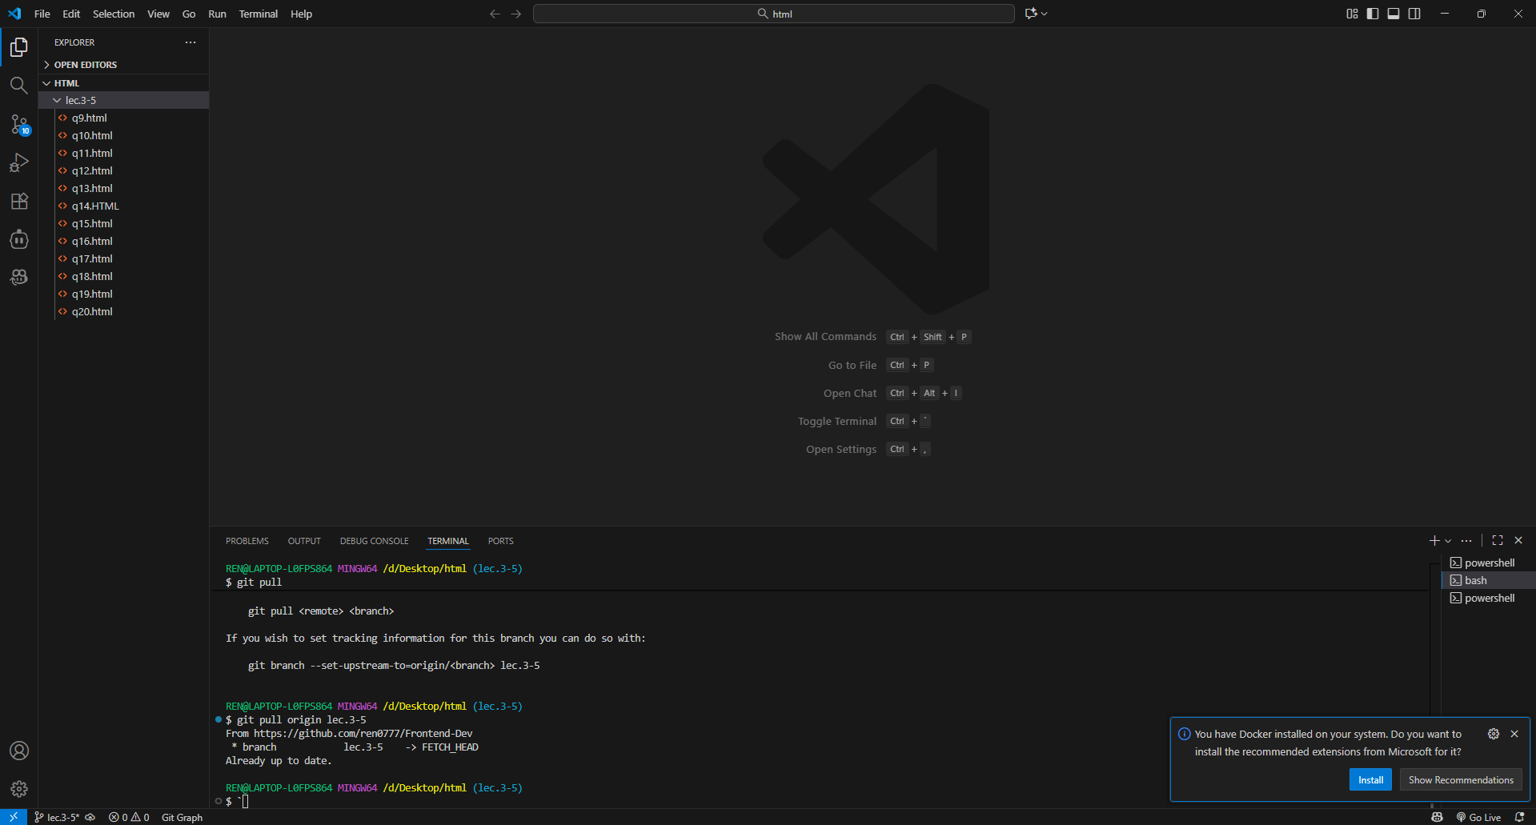

QUES 8. Explain the difference between static and dynamic websites. Provide an example of
each.
ANS. Static Website: Content is fixed; every visitor sees the same content. Example: Personal portfolio page built with only HTML and CSS — like aboutme.html.​
Dynamic Website: Content changes based on user input/time; uses server-side processing. Example: E-commerce site where product listings or user dashboards change dynamically (e.g., Amazon, WordPress blog).​

QUES 9. Research and list five web browsers. Explain how rendering engines differ between
them.
ANS.
Browser | Rendering Engine
Google Chrome | Blink
Mozilla Firefox | Gecko
Apple Safari | WebKit
Microsoft Edge | Blink
Opera | Blink/Goanna
- Rendering engines determine how browsers interpret and display HTML, CSS, and JavaScript. Chrome, Edge, and Opera use Blink; Firefox uses Gecko; Safari uses WebKit.

QUES 10. Draw a labeled diagram showing the basic web architecture flow — client, server,
database, and APIs.
ANS.
- Client: Browser or mobile app sends HTTP requests.
- Server: Hosts the web app; processes logic, communicates with both client (via APIs) and database.
- Database: Stores and manages data.
- APIs connect frontend (client) with backend (server/data).

